

MINI-PROJECT REPORT - WEB TECHNOLOGIES LAB  
  
DEPARTMENT OF DATA SCIENCE & COMPUTER APPLICATIONS   
  
  
**MANIPAL MINCE**

|  |  |
| --- | --- |
| ANKIT RAJ | 200968220 |
| J. VENKAT VARDHAN | 200968158 |
| K. SAINATH REDDY | 200968240 |
| RAHUL PANDOVE | 200968252 |
| G. VAMSI KRISHNA | 200968172 |
| JAITHRA VARMA | 200968254 |

B. TECH IN DATA SCIENCE ENGINEERING  
Compiled by

**Mentored By:**

**Tojo Thomas Akshay Bhat**

Assistant Professor-Senior Scale Assistant Professor-Senior Scale

DSCA, MIT DSCA, MIT

## CERTIFICATE

This is to certify that Ankit Raj (200968220), Rahul Pandove (200968252), J. Venkat   
Vardhan (200968158), K. Sainath Reddy (200968240), Vamsi Krishna (200968172) and Jaithra Varma (200968254), have successfully compiled a mini project titled “Food-Ordering Portal” rightly bringing forth the competencies and skill sets they gained during the course - Web Tech Lab (DSE 3163) and thereby resulting in the culmination of this project.

**Tojo Thomas Akshay Bhat**

Assistant Professor-Senior Scale Assistant Professor-Senior Scale

DSCA, MIT DSCA, MIT

**CONTENTS**

|  |  |
| --- | --- |
| INTRODUCTION | 4 |
| MOTIVATION | 5 |
| OBJECTIVES | 6 |
| METHODOLOGY | 7 |
| ROLE DESCRIPTION | 8 |
| SOFTWARE REQUIREMENTS | 9 |
| FRONTEND | 11 |
| BACKEND | 12 |
| DATABASE | 14 |
| SCHEMA DIAGRAM | 18 |
| UML USE-CASE DIAGRAM | 19 |
| MODULES | 20 |
| DESIGN | 21 |
| LEARNING CURVE | 26 |
| CONCLUSION | 27 |
| FUTURE SCOPE | 28 |
| REFERENCES | 29 |

**INTRODUCTION**

The aim of this project is to build an online food-ordering portal for a Mexican restaurant. The users can visit and sign up to create a user account for themselves. The user can then use the credentials to log in to the portal and place the food order. The portal is restricted for ordering from a single restaurant but can be scaled to connect multiple restaurants and act as a single food ordering platform through which people can place orders from different restaurants nearby them.

The website is interactive and provides users with various recommendations about the type of food they should order and various offers that are being given on different food items.

The website also contains an admin module which helps the restaurants to manage their menu and food item. The database is updated manually by the admins if they make any changes.

**MOTIVATION**

In this digital era, customers value convenience the most and they are willing to pay extra for something if the service provided is good enough. This food-ordering portal allows the restaurant to make their online presence and allow customers to place their order online and get it delivered to their home. Thereby increasing the reach of the restaurants as well as providing service to the customers at the same time.

**OBJECTIVES**

* Build an interactive food ordering portal pertaining to a single restaurant which then can be scaled to include multiple restaurants as required.
* Provide the customers with various lucrative offers and combos which provides convenience and generates revenue for the restaurant owners at the same time.
* Provide a seamless and glitch free experience to the customers by using latest web technologies and frame-works like Vue.Js, NodeJs, MySQL, Express, axios etc.
* Integrating an admin module to the website so that the food menu, prices, offer combos can be updated and deleted as per the availability regularly.

**METHODOLOGY**

**AGILE**

Agile is a structured and iterative approach to project management and product development.  
It is an alternative to waterfall or traditional sequential development. It is a time-focused philosophy that allows creating a project incrementally, dividing it into small pieces. One of the main benefits is the ability to adapt and change at any step of the project.

When we use an agile approach, we work on **sprints.** They are a set amount of time within which a task should be completed. After the completion of each sprint, we analyze and assess the changes that are needed and we can introduce new ideas ahead of the next sprint. We can introduce new ideas ahead of the next sprint.

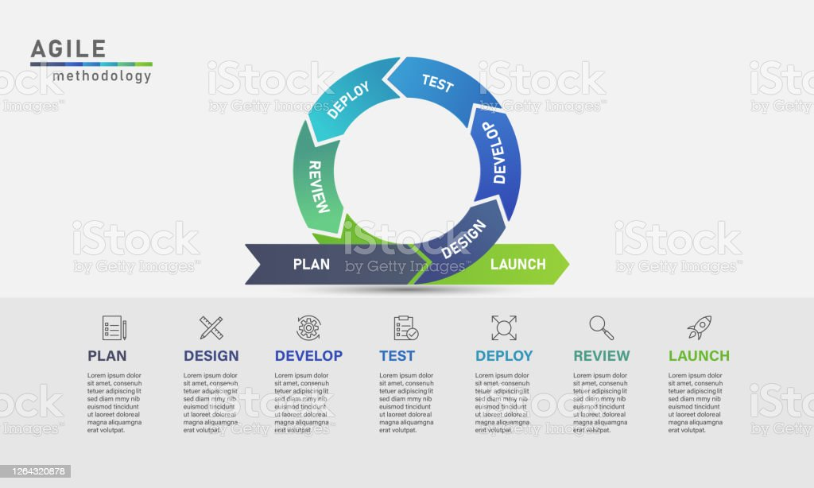

**ROLE DESCRIPTION**

|  |  |
| --- | --- |
| **Names** | **Roles** |
| Ankit Raj | Front End |
| J. Venkat Vardhan | UI/UX |
| K. Sainath Reddy | Database and Documentation |
| Rahul Pandove | Back End and Database |
| Jaithra Varma | Research and Documentation |
| G. Vamsi Krishna | Front End |

**SOFTWARE REQUIREMENTS**

* **VS Code**

VS Code is an open-source, source code editor particularly in web development. It's fast, extensible, customizable and has tons of features. This editor is used to write, run and debug the HTML, CSS and JavaScript codes required for building a project.

* **Figma**

Figma is a free web-based designing tool that consists of powerful and eye-catching features for creating UI/UX design in web development. It is used to create a user interface for a project.

* **Bootstrap**

Bootstrap is a free, open-source front-end development framework for the creation of websites and web apps. Designed to enable responsiveness of mobile-first websites, Bootstrap provides a collection of syntax for template designs that are customizable and easy to use.

* **MySQL**

**MySQL** is an [open-source](https://en.wikipedia.org/wiki/Open-source_software) [relational](https://en.wikipedia.org/wiki/Relational_database_management_system) [database](https://en.wikipedia.org/wiki/Relational_database_management_system) [management](https://en.wikipedia.org/wiki/Relational_database_management_system) [system](https://en.wikipedia.org/wiki/Relational_database_management_system) (RDBMS), which organizes data into one or more data tables in which data may be related to each other. MySQL has stand-alone clients that allow users to interact directly with a MySQL database using SQL, but more often, MySQL is used with other programs to implement applications that need relational database capability.

* **NodeJS**

Node.js is a JavaScript runtime environment that allows JS to run outside a web browser. It is one of the most efficient cross-platform JavaScript environments that can help you build robust and effective REST APIs, mobile applications, and web applications. Express is a flexible backend framework of Node.js that supports the development of API by creating POST and GET requests to fetch the data from the database or an external server.

* **VueJS**

VueJS is an [open-source](https://en.wikipedia.org/wiki/Open-source_software) [model–view–viewmodel](https://en.wikipedia.org/wiki/Model%E2%80%93view%E2%80%93viewmodel) [front](https://en.wikipedia.org/wiki/Front_end_and_back_end) [end](https://en.wikipedia.org/wiki/Front_end_and_back_end) [JavaScript framework](https://en.wikipedia.org/wiki/JavaScript_framework) for building [user](https://en.wikipedia.org/wiki/User_interface) [interfaces](https://en.wikipedia.org/wiki/User_interface) and [single-page](https://en.wikipedia.org/wiki/Single-page_application) [applications](https://en.wikipedia.org/wiki/Single-page_application). Vuex is a state management pattern + library for Vue.js applications. It serves as a centralized store for all the components in an application, with rules ensuring that the state can only be mutated in a predictable fashion.

* **Git & GitHub**

GitHub is a cloud-based platform used for storing, tracking, and collaborating on software projects. It enables developers to upload their own code files and to collaborate with fellow developers on open-source projects. While Git is a version control system that helps in managing files on the local system and cloud-based platforms like GitHub and GitLab in project development and management.

**FRONTEND**

The entire front-end part of the website was built using HTML, CSS and JavaScript. We also used a library Vue.js, which is an [open-source](https://en.wikipedia.org/wiki/Open-source_software) [model–view–view](https://en.wikipedia.org/wiki/Model%E2%80%93view%E2%80%93viewmodel) [model](https://en.wikipedia.org/wiki/Model%E2%80%93view%E2%80%93viewmodel) [front](https://en.wikipedia.org/wiki/Front_end_and_back_end) [end](https://en.wikipedia.org/wiki/Front_end_and_back_end) [JavaScript](https://en.wikipedia.org/wiki/JavaScript_framework) [framework](https://en.wikipedia.org/wiki/JavaScript_framework) for building [user interfaces](https://en.wikipedia.org/wiki/User_interface) and [single-page](https://en.wikipedia.org/wiki/Single-page_application) [applications](https://en.wikipedia.org/wiki/Single-page_application). It is used in the creation of websites and web-apps, designed to enable responsiveness and provides a collection of usable syntax for template designs that are customizable and easy to use. Files are pre-compiled which the users can just run directly in their website.

**BACKEND**

The backend consists of files written in node.js for combining all the backend entities.

All the routes in this project are designed using Express framework.

We have used APIs based on the POST, GET and DELETE methods in our project.

There are 5 routes for the Food collection:

* Get information about all foods
* Get information about food by ID
* Post a new food
* Put an update on food
* Delete food

There are 2 routes for the User Information:

* Get User information
* Post a new Account

There are 6 routes for the Cart information:

* Post an added item to cart
* Get an item in cart
* Put update on quantity of item
* Delete item in cart
* Delete all items in cart

There are 8 routes for Bill Status:

* Get bill status
* Post a new bill status
* Get all bills filtered by user
* Get all bills filtered by bill
* Get all bills
* Put update on bill status
* Put update on bill paid
* Put update on cancel Bill Status

**DATABASE**

The database used in this project is MySQL. MySQL, accessed with XAMPP

Control Panel, is an open-source relational database which organizes data with the relations between tables which help structure the data. SQL(Structured Query Language) is a language used to create, modify and extract data from relational databases and also control user access to the database. MySQL works with an operating system to implement a relational database in a computer’s storage system, manages users, allows access to the network, facilitates database integrity and allows creation of backups.

We mainly used MySQL for creating the required tables for storing the user details, food details, cart, bill details, bill status. When a random user creates his/her profile in the website, the details entered will gets stored in the user table in the database. Same goes for the detail of food items available, the order cart and bill summary.

**Register Page**

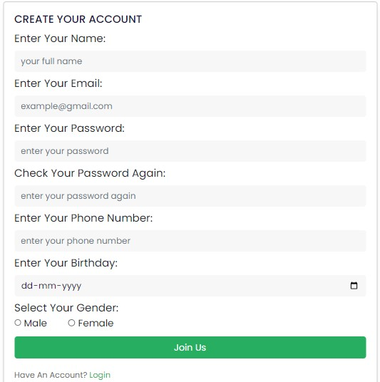

**FOOD TABLE**

|  |  |  |  |
| --- | --- | --- | --- |
| Field Name | Primary Key | Data Type | Field Size |
| Food Id | Primary Key | Int | 11 |
| Food_name | - | Varchar | 255 |
| Food_star | - | Varchar | 255 |
| Food_vote | - | Varchar | 255 |
| Food_price | - | Varchar | 255 |
| Food_discount | - | Varchar | 255 |
| Food_desc | - | Varchar | 255 |
| Food_status | - | Varchar | 255 |
| Food_type | - | Varchar | 255 |
| Food_category | - | Varchar | 255 |
| Food_src | - | Varchar | 255 |

**USER TABLE**

|  |  |  |  |
| --- | --- | --- | --- |
| User_id | Primary Key | Int | 11 |
| User_name | - | Varchar | 255 |
| User_email | - | Varchar | 255 |
| User_phone | - | Varchar | 255 |
| User_password | - | Varchar | 255 |
| User_birth | - | Varchar | 255 |
| User_gender | - | Varchar | 255 |

**CART TABLE**

|  |  |  |  |
| --- | --- | --- | --- |
| User_id | Primary Key | Int | 11 |
| Food_id | Primary Key | Int | 11 |
| Item_qty | - | Int | 25 |

**BILL DETAILS TABLE**

|  |  |  |  |
| --- | --- | --- | --- |
| Bill_id | Primary Key | Int | 11 |
| Food_id | Primary Key | Int | 11 |
| Item_qty | - | Int | 25 |

**BILL STATUS TABLE**

|  |  |  |  |
| --- | --- | --- | --- |
| Bill_id | Primary Key | Int |  |
| User_id | - | Int |  |
| Bill_phone | - | Varchar | 255 |
| Bill_address | - | Varchar | 255 |
| Bill_when | - | Varchar | 255 |
| Bill_method | - | Varchar | 255 |
| Bill_discount | - | Int |  |
| Bill_delivery | - | Int |  |
| Bill_total | - | Int |  |
| Bill_paid | - | Varchar | 255 |
| Bill_status | - | Int |  |

**SCHEMA DIAGRAM**

**UML USE-CASE DIAGRAM**

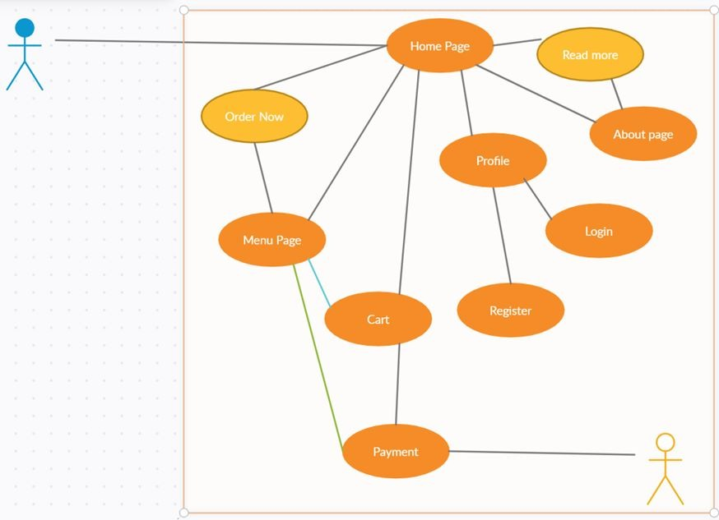

**MODULES**

**Home:** This is the first webpage that opens on visiting the website. It contains various running offers on dishes and has links to to visit the menu section, about section through a navbar component which contains link to other sections of the web site.

**Dashboard:** This module is only accessible by the admin and it contains the details about each order. Various details about the order such as bil Id, User Id, Phone, Address of the customer, timestamp of the order placed,Payment status, Order status and the actions which need to be taken next.  
  
**Register:** The users which are visiting the website for the first time need to create an account which will then be used by them to login and place orders.  
  
**Login:** The registered users can then login to the website using the e-mail Id and password that they have set for their account.  
  
**My Order:** This module shows the details of each order placed by the user. The details include bill amount, payment status, time of order placement, address and phone number of the user.  
  
**Cart:** This module takes care of the summary of all the food items that are added to be ordered, it contains discounts if applicable, the delivery fee, the total amount and a checkout as well as a cancel button to serve the users.  
  
**Checkout:** The checkout module prompts the user to fill in the shipping details, payment mode and details and then finally the order is placed.

**DESIGN**

* The design of the UI and UX is prepared using figma. The color scheme consists of a shade of green, which greatly resembles the color of food in most parts of the world, and is aesthetically pleasing so it was chosen as the color of choice.
* The navbar component is placed at the top and is integrated into each page of the website. It contains links to all the pages present in the website.
* The cart and the profile icon present in the navbar allows the users to access the cart and their profile respectively.
* The Footer component consists of links to various social media handles of the particular restaurant. The operating time of the restaurant and extra links to the login and registration module.

**The landing page**

**Footer of Home Page**

**About Page**

**Menu Page**

**Login Page**

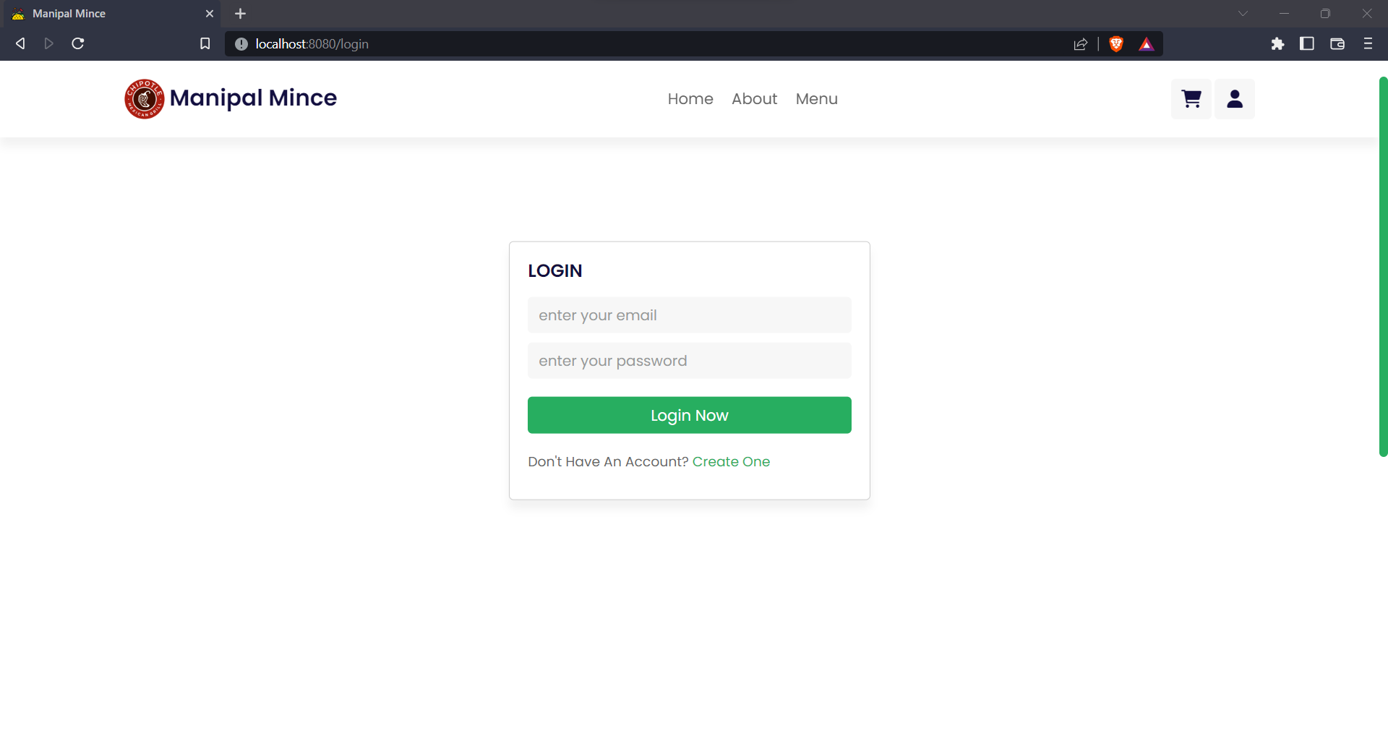

**Cart Page**

**MyOrder Page**

**LEARNING CURVE**

We have come a long way since we started this project. Initially we had little to no knowledge of web development but with the motivation given by Tojo sir and Akshay sir, we started learning new skills and implementing them in our project. Despite many hurdles we faced, our team was strong and we have great team members who are achievers in different fields. Our members previous experience and passion towards tech has greatly boosted the progress of the project. We learned about how to build an end to end working website. We hope that we continue learning new technologies and excel in this techworld.

**CONCLUSION**

Manipal Mince is a one stop destination for people to taste some of the most famous delicacies in the world at your home with just a click away. Our site’s marvelous user interface makes it very comfortable for users to order food. Through this project our knowledge and skill set was expanded and also learned a lot about teamwork and also improved our communication skills.

Project Outcomes :

* Came across many new tools and technologies as part of this project and learnt to work collaboratively as a team and communicate with each other trying to achieve the final output.
* Implemented the login authentication successfully.
* Successfully established a connection with MySQL
* Menu been displayed by extracting the data from the database
* Added additional features such as special discounts on eataries

**FUTURE SCOPE**

* Can try to enhance the user experience by including the option of selecting a city rather than confining to a single location.
* Can include a feature to book a table in a particular restaurant.
* Can carry out the authentication process using your Google, Instagram account etc.
* Recommend eateries to customers based on ratings and feedbacks.
* Integrating with payment gateways and UPI.
* Making it available as an Android or iOS app.

**REFERENCES**

* <https://nodejs.org/en/docs/>
* <https://expressjs.com/>
* [https://www.youtube.com/watch?v=1wXYg8Eslnc&list=WL&index=8&t=8 55s](https://www.youtube.com/watch?v=1wXYg8Eslnc&list=WL&index=8&t=855s)
* <https://www.youtube.com/watch?v=lYVKbAn5Od0>
* <https://vuejs.org/>
* <https://www.youtube.com/c/CodeWithHarry>
* <https://creately.com/blog/diagrams/uml-diagram-types-examples/>
* [https://www.lucidchart.com](https://www.lucidchart.com/)